Part 1:
If the signal does not reinstall itself, the signal will not respond properly. For an example where the signal SIGINT does not reinstall itself, the first SIGINT will be caught, but the second SIGINT will not do anything. When the signal is reinstalled, the SIGINT will be caught the first time, and the second time the SIGINT will execute.

Part 2:
Q1: The only two signals that can be called through the terminal are SIGINT (ctrl+c) and SIGSTOP(ctrl+z). When SIGINT is first called, it will return the Signal number and Thread id and continue running. The second time it is called it will terminate the program. SIGSTOP cannot be caught/blocked/stopped so if it is called the program will automatically stop.
SIGINT Called Once:
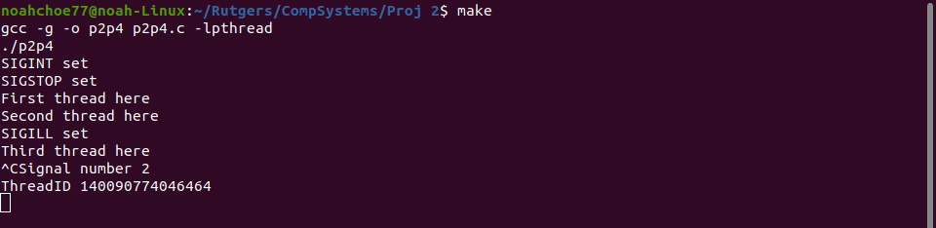
SIGINT Called Twice:
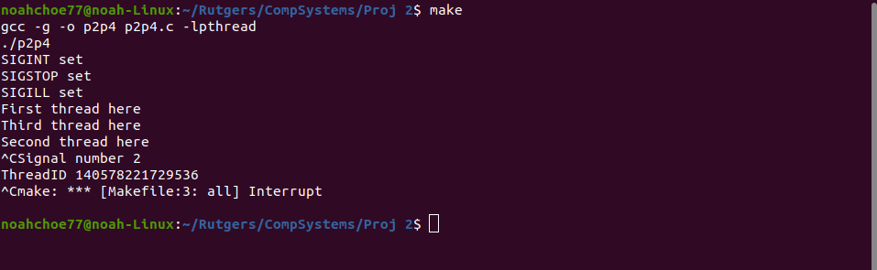

SIGSTOP Called:
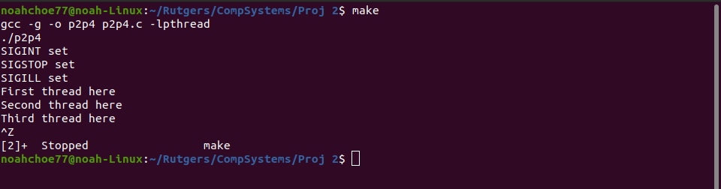

Q2:
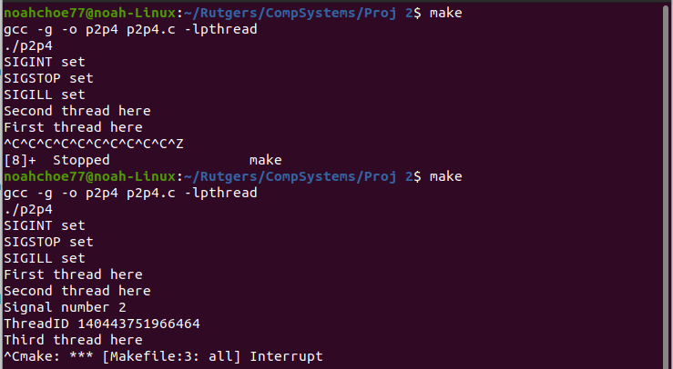
For one thread sending a signal to another thread, the signal will be caught if it can be caught. In the code above we see two instances. The first is sending SIGSTOP to the SIGSTOP thread. When this happens, as soon as SIGSTOP is received the program is terminated. The second shows SIGINT being sent from the SIGSTOP thread which is caught and calling SIGINT again will terminate the program.
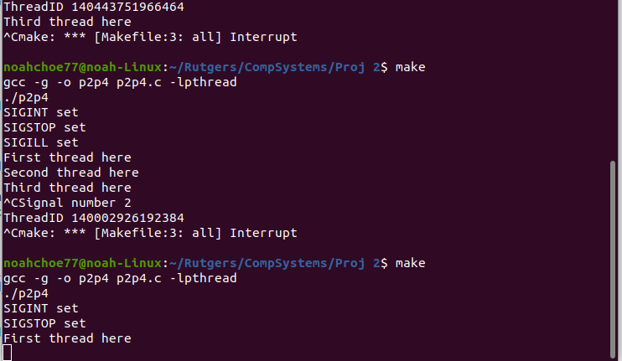
For the signal calls to the main method, they will not run. We see that SIGINT still ran as normal, however, when SIGSTOP was called to main it stopped the program as soon as the signal was sent because SIGSTOP cannot be caught/blocked/ignored.

